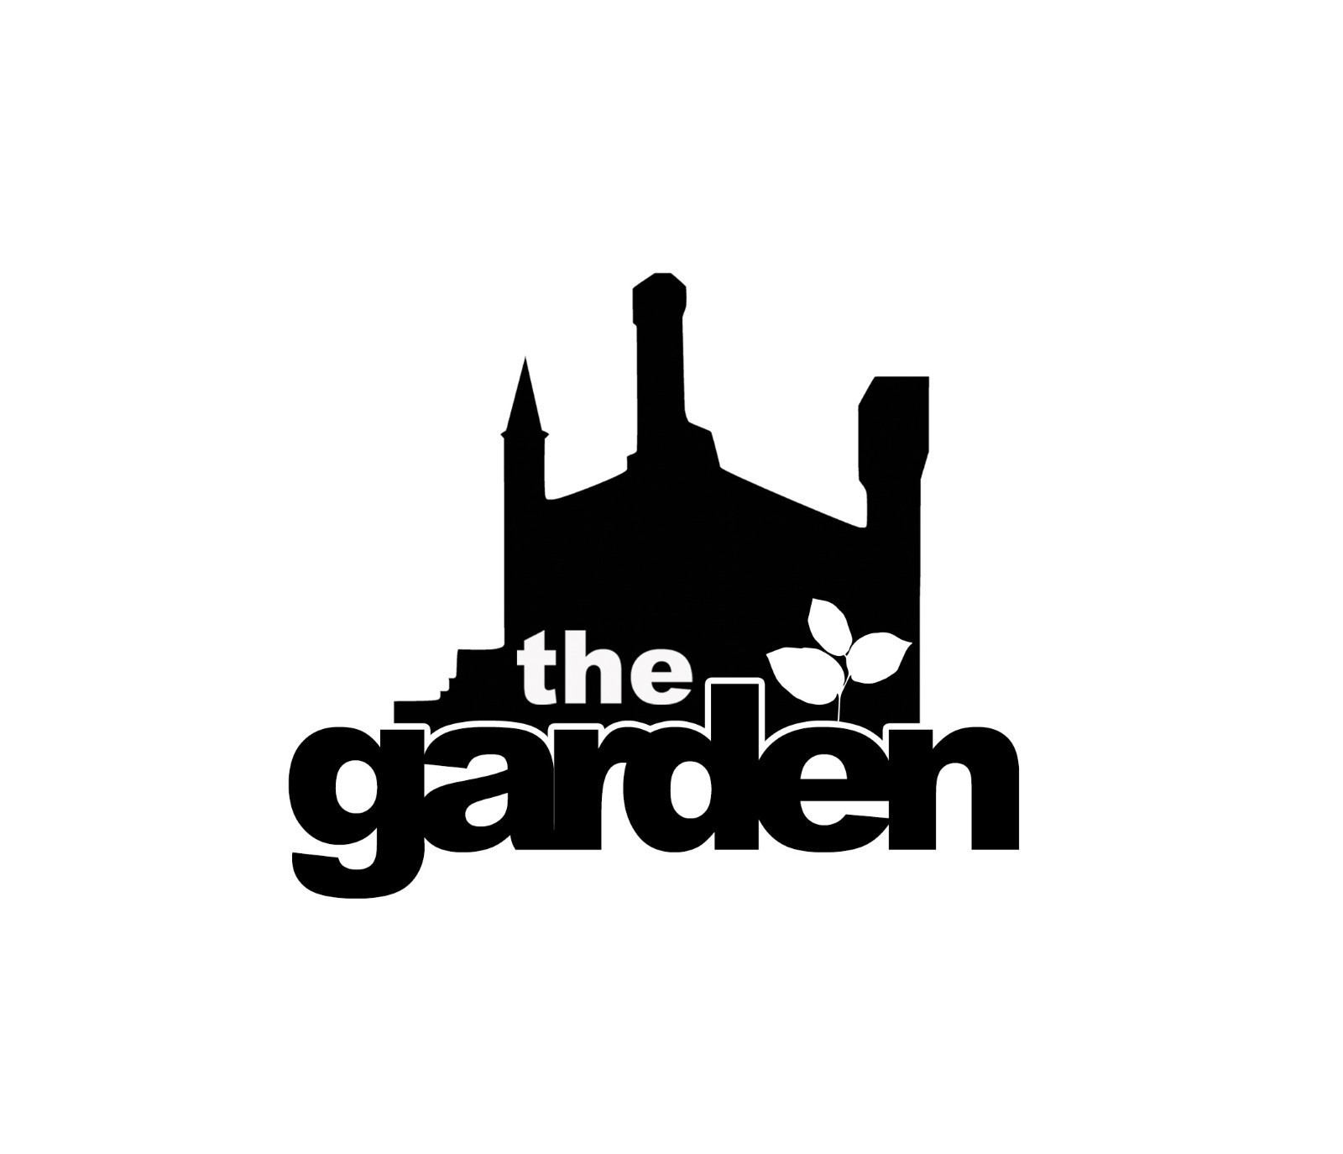
Volunteer Induction Form
For The Castle Garden

Your contact details:
Name

Address

Telephone

Email
Please write clearly!
We will add you to our mailing list. Please tick if you would not like to be added

Please provide us with details of someone we may contact in case of an emergency:
Name

Telephone

- What would you like to gain from volunteering with The Castle Garden Project?

- What experience/skills do you have that may be relevant for working with us?

- Are you a castle member and climber? YES/NO
- If not, are you interested in learning to climb and becoming a member?

- Do you have any health needs that we may need to know about? e.g. bee sting allergy, nut allergy...etc
- Have you had a tetanus injection in the last 10 years? YES/NO
- Are there any aspects of working with us that might mean that you require extra support or input?
Signed......................................................................................Date.....................................
I confirm that I have read and understood the Castle Garden Risk Assessment, Health and Safety checklist Equal Opportunities Policy.

Please return this completed form to garden@castle-climbing.co.uk You will then be sent dates for availability on our inductions, which you can book onto.
If you have any issues filling out or returning the form, please just let us know and we will accommodate you.

